*Objective*

The objective of this phase is to provide a complete data processing model that allows a student to take, enroll, practice, and view their grades. The student can also view their upcoming exams in their Student Schedule. The instructor can create assessments and practice tests of different question type so test the student’s knowledge.

*Back-end Models and Tools*

**Database design**

Entities, their attributes, and relationships were modelled using LucidChart. This schema was then converted to MariaDB compatible queries using LucidChart’s export functionality.

**Entity Relationship Diagram (ERD)**

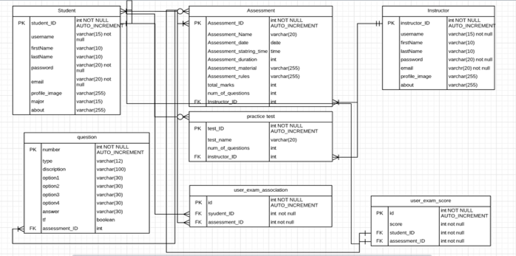

**Development Environment**

We used the Apache HTTP Server and the MariaDB RDBMS as part of the XAMPP (X-platform, Apache, MariaDB, PHP, Perl) stack as our development environment. We also collaborated with each other using the Git VCS and GitHub.

*Changes in Front End Screens*

**My Exam Landing Page**

Before 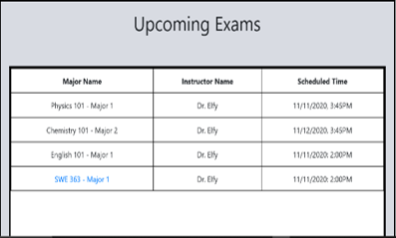

After

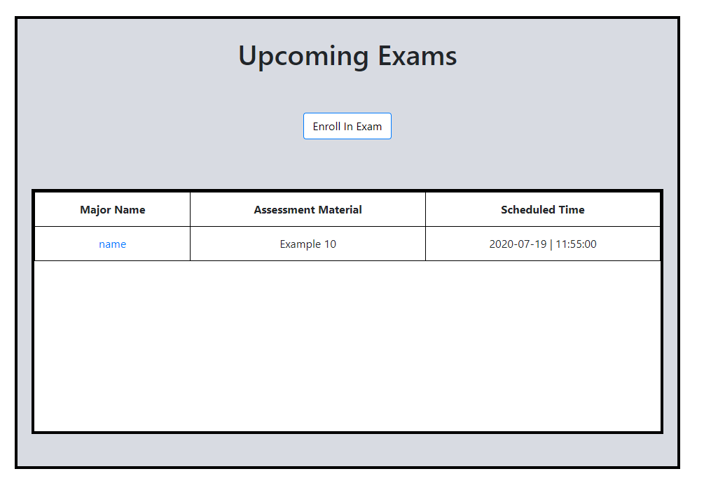

The user interface was changed to accommodate different data. New functionality added that allows user to enroll in Exams.

**Create Test Landing Page**

Before

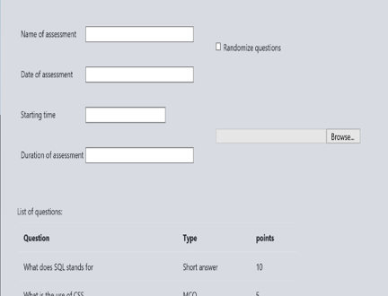

After  
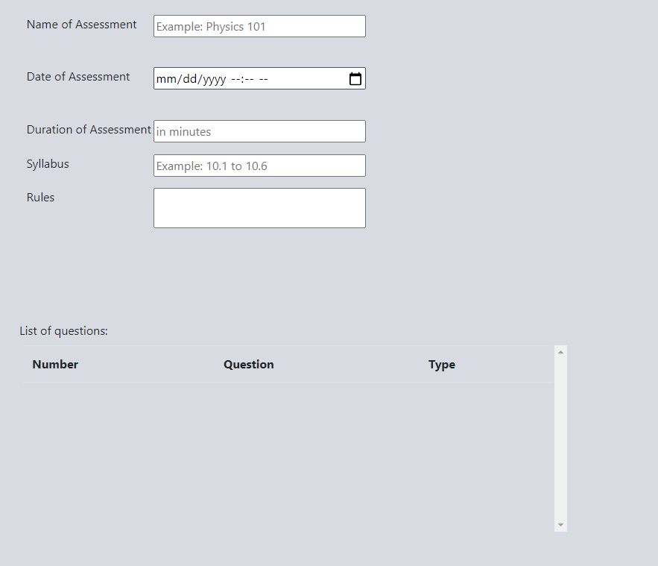

File input and Randomize questions were removed from the UI. The Starting Time field was merged with the Date of Assessment field to prevent a lot of unstructured data from being passed around. Two new inputs were added to allow the instructor to add rules and syllabus of the assessment.

**Exam Question Page**

Before

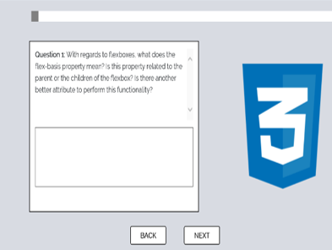

After

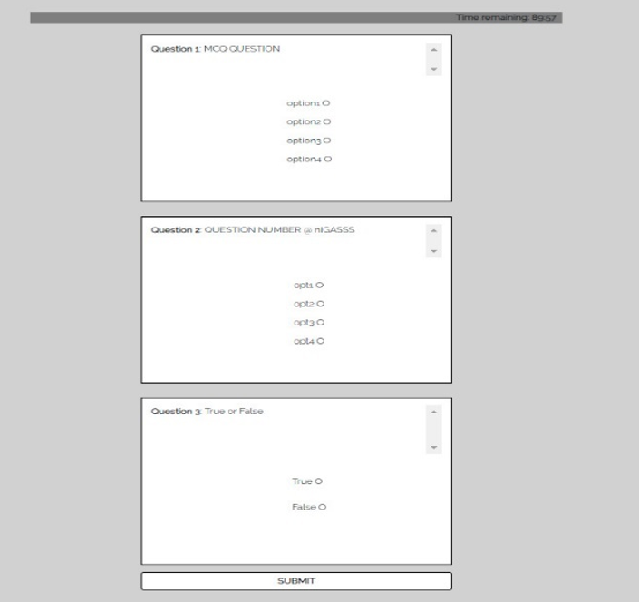

Instead of questions being showed one by one, we decided to show them all together.

**Account Page**

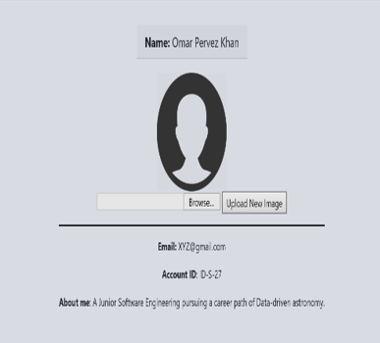

The account page was completely removed from the system. It held no purpose as we had not implemented the functionality of letting user’s view other user’s profiles.

**Navigation Bar**

Before



After

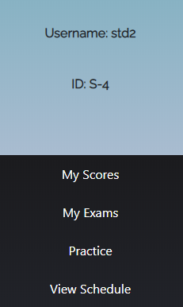

As the profile page was removed, there was no purpose of having a profile picture of the user. Hence, the profile picture was removed from the navigation bar.

**View Scores Page**

The View Scores page had to be removed as we could not implement the functionality to grade students in time.

*Work Distribution*

Omar Pervez Khan (201746350):

* Exam Question Page
* Exam Start Page
* My Exams Page
* Create Assessment Page
* Add Question Modal
* Create Practice Test Page
* Instructor Schedule Page
* Sign up Page
* Sign in Page

Hamed Alotibi (201730830):

* Student Practice Landing Page
* Student Schedule Page
* Student Detailed Practice Page
* Create Practice Test Page
* View Student Scores
* Add Question Modal

Abdulaziz Ismaeil (201685300):

* Sign up Page
* Sign in Page
* Instructor Schedule Page
* Student Schedule Page
* My Exams Page